Project Title: Smart Fashion Recommender Application Project Design Phase-I - Solution Fit Template Team ID: PNT2022TMID17944

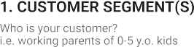

Online shopping gives New Collections

pros: Easy to use

cons: customer confused

when have lost of collections

Money and Network Connection

The Customers are Adults and children

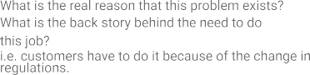

Customers need to be with new fashions for current trends

Customers spend the time to

find the new fashion clothes

Users hard to find Trending Fashion Clothes.

|  |  |  |  |  |  |  |  |
| --- | --- | --- | --- | --- | --- | --- | --- |
|  | **3. TRIGGERS TR**  What triggers customers to act? i.e. seeing their neighbour installing solar panels, reading about a more efficient solution in the news. | | | | **10. YOUR SOLUTION SL**  If you are working on an existing business, write down your current solution first, fill in the canvas, and check how much it fits reality.  If you are working on a new business proposition, then keep it blank until you fill in the canvas and come up with a solution that fits within customer limitations, solves a problem and matches customer behaviour.  Make a ChatBot Assistant for shopping with customers and send notifications when new collections arravied | 1. **CHANNELS of BEHAVIOUR CH**    1. **ONLINE**   What kind of actions do customers take online? Extract online channels from #7   * 1. **OFFLINE**   What kind of actions do customers take offline? Extract offline channels from #7 and use them for customer development.  ONLINE: Customers buy the new clothes  OFFLINE: Customers will use the clothes |  |
|  |  | Seeing neighbor Dressing Styles |  |
| **4. EMOTIONS: BEFORE / AFTER EM**  How do customers feel when they face a problem or a job and afterwards?  i.e. lost, insecure > confident, in control - use it in your communication strategy & design.  Felling Sad and Frustration > Selfconfident | | | |